1.#include <stdio.h>

struct Student {

char name[50];

int age;

float totalMarks;

};

int main() {

struct Student student1, student2;

float averageMarks;

printf("Enter details for Student 1:\n");

printf("Name: ");

scanf(" %[^\n]s", student1.name);

printf("Age: ");

scanf("%d", &student1.age);

printf("Total Marks: ");

scanf("%f", &student1.totalMarks);

printf("\nEnter details for Student 2:\n");

printf("Name: ");

scanf(" %[^\n]s", student2.name);

printf("Age: ");

scanf("%d", &student2.age);

printf("Total Marks: ");

scanf("%f", &student2.totalMarks);

printf("\nStudent 1 Details:\n");

printf("Name: %s\n", student1.name);

printf("Age: %d\n", student1.age);

printf("Total Marks: %.2f\n", student1.totalMarks);

printf("\nStudent 2 Details:\n");

printf("Name: %s\n", student2.name);

printf("Age: %d\n", student2.age);

printf("Total Marks: %.2f\n", student2.totalMarks);

averageMarks = (student1.totalMarks + student2.totalMarks) / 2;

printf("\nAverage of Total Marks: %.2f\n", averageMarks);

return 0;

}

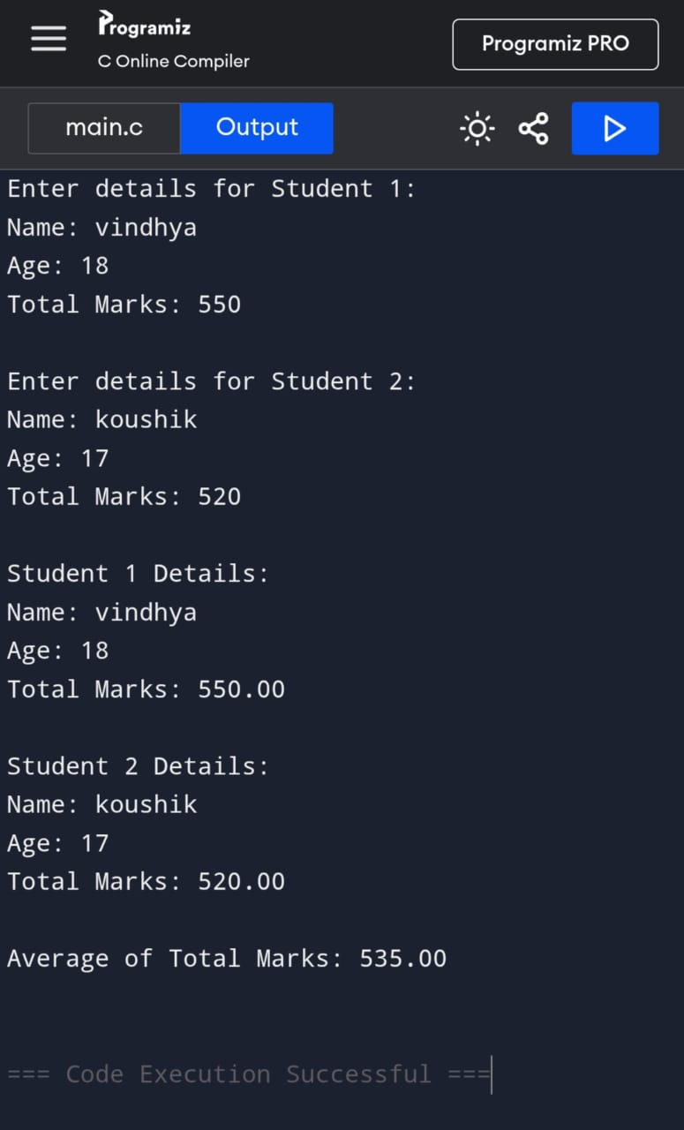

2.#include <stdio.h>

struct Car {

int carID;

char model[50];

float rentalRatePerDay;

};

int main() {

struct Car cars[3];

int numberOfDays;

float totalCost;

for (int i = 0; i < 3; i++) {

printf("Enter details for Car %d:\n", i + 1);

printf("Car ID: ");

scanf("%d", &cars[i].carID);

printf("Model: ");

scanf(" %[^\n]s", cars[i].model);

printf("Rental Rate per Day: ");

scanf("%f", &cars[i].rentalRatePerDay);

printf("\n");

}

printf("Enter the number of days for rental: ");

scanf("%d", &numberOfDays);

printf("\nCar Rental Details:\n");

for (int i = 0; i < 3; i++) {

totalCost = cars[i].rentalRatePerDay \* numberOfDays;

printf("Car ID: %d\n", cars[i].carID);

printf("Model: %s\n", cars[i].model);

printf("Rental Rate per Day: %.2f\n", cars[i].rentalRatePerDay);

printf("Total Cost for %d days: %.2f\n\n", numberOfDays, totalCost);

}

return 0;

}

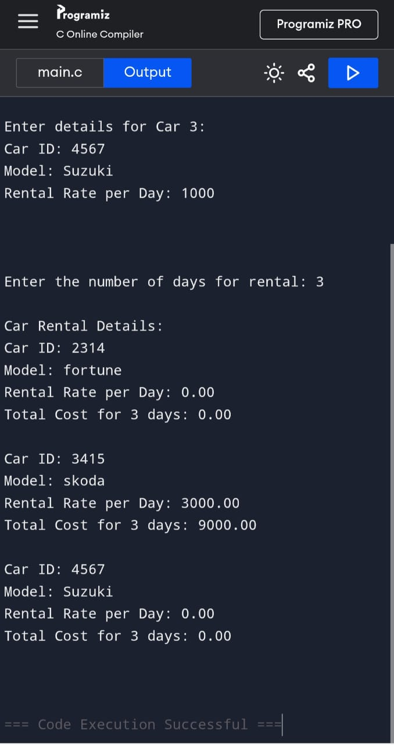

3.#include <stdio.h>

struct Complex {

float real;

float imaginary;

};

struct Complex addComplex(struct Complex c1, struct Complex c2) {

struct Complex result;

result.real = c1.real + c2.real;

result.imaginary = c1.imaginary + c2.imaginary;

return result;

}

struct Complex multiplyComplex(struct Complex c1, struct Complex c2) {

struct Complex result;

result.real = (c1.real \* c2.real) - (c1.imaginary \* c2.imaginary);

result.imaginary = (c1.real \* c2.imaginary) + (c1.imaginary \* c2.real);

return result;

}

int main() {

struct Complex c1, c2, sum, product;

printf("Enter the real and imaginary parts of the first complex number:\n");

scanf("%f %f", &c1.real, &c1.imaginary);

printf("Enter the real and imaginary parts of the second complex number:\n");

scanf("%f %f", &c2.real, &c2.imaginary);

sum = addComplex(c1, c2);

product = multiplyComplex(c1, c2);

printf("\nResults:\n");

printf("Sum: %.2f + %.2fi\n", sum.real, sum.imaginary);

printf("Product: %.2f + %.2fi\n", product.real, product.imaginary);

return 0;

}

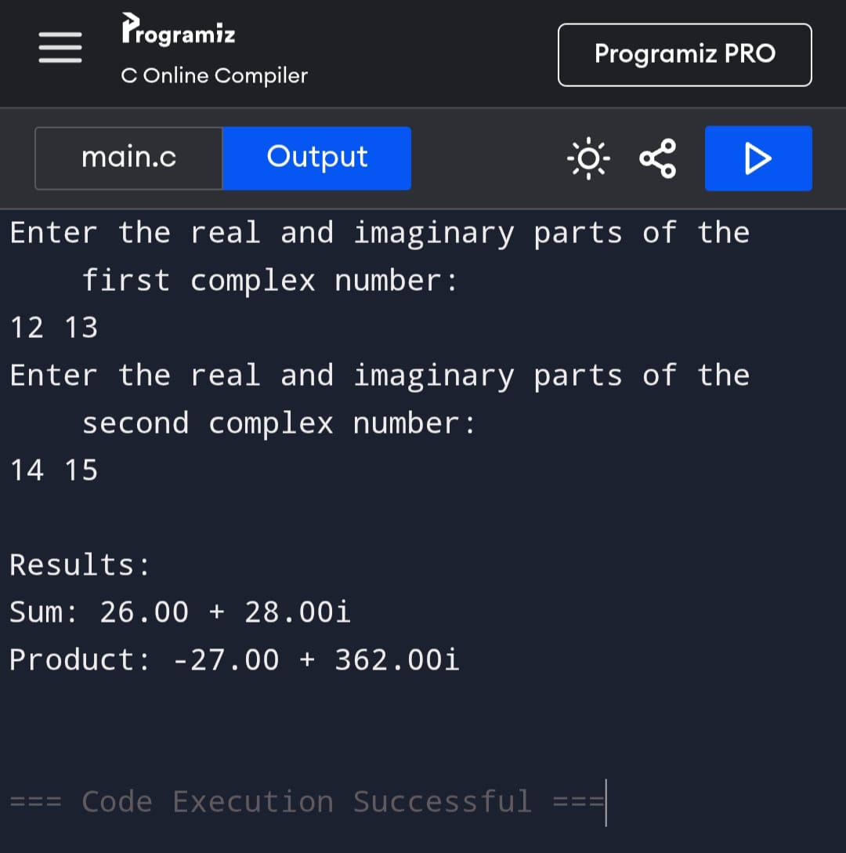

4.#include <stdio.h>

#include <stdlib.h>

struct Employee {

int id;

char name[50];

float salary;

};

int main() {

struct Employee \*employees;

int n;

printf("Enter the number of employees: ");

scanf("%d", &n);

employees = (struct Employee \*)malloc(n \* sizeof(struct Employee));

if (employees == NULL) {

printf("Memory allocation failed!\n");

return 1;

}

for (int i = 0; i < n; i++) {

printf("\nEnter details for Employee %d:\n", i + 1);

printf("ID: ");

scanf("%d", &employees[i].id);

printf("Name: ");

scanf(" %[^\n]s", employees[i].name);

printf("Salary: ");

scanf("%f", &employees[i].salary);

}

printf("\nEmployee Details:\n");

for (int i = 0; i < n; i++) {

printf("\nEmployee %d:\n", i + 1);

printf("ID: %d\n", employees[i].id);

printf("Name: %s\n", employees[i].name);

printf("Salary: %.2f\n", employees[i].salary);

}

free(employees);

return 0;

}

